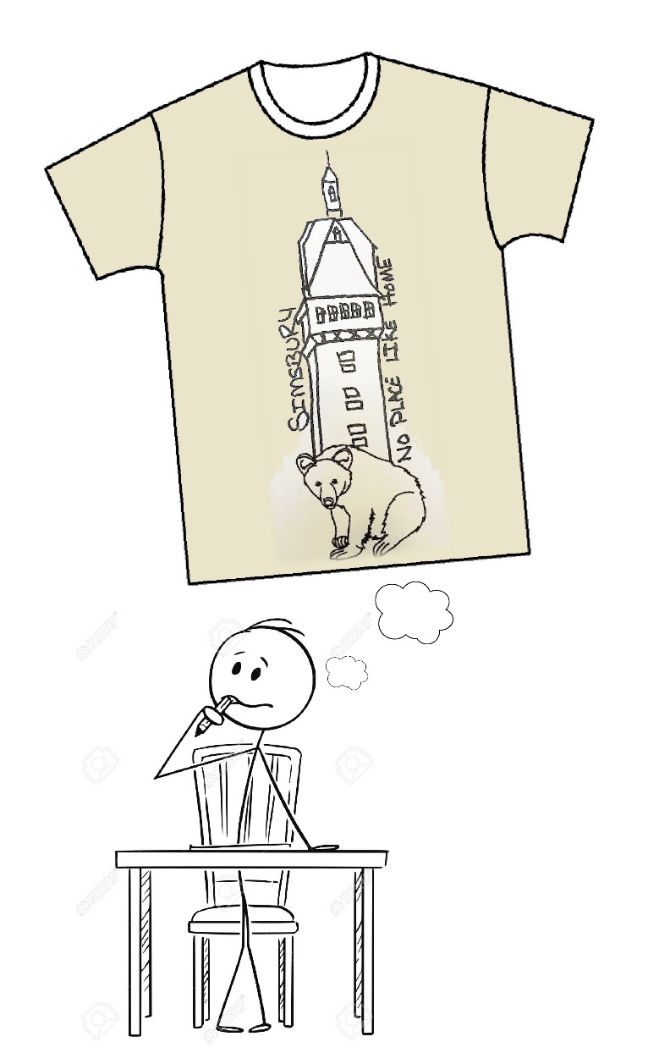
SIMSBURY: NO PLACE LIKE HOME
ART CONTEST

Simsbury Main Street Partnership (SMSP) invites all school-aged children K-12, of Simsbury, CT to participate in our First Annual “Simsbury: There’s No Place Like Home” t-shirt art contest!

Winners from each age group will receive:
- $500 College Savings CD at Premier Sponsor Liberty Bank
- Pizza Party delivered to each winner’s home
- A t-shirt with their winning design
- And, the schools that produce the winning artists will receive a $500 donation to their art
- department!

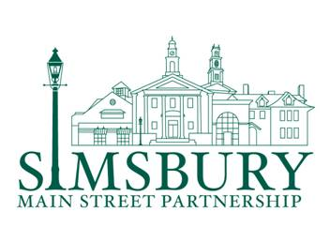
See official contest rules at http://www.shopsimsbury.com/simsburyartcontest

