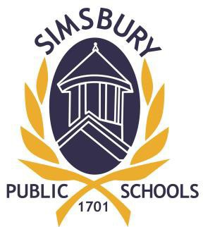



**Simsbury Public Schools**

**2022 Flexible Spending Accounts**

**Enrollment**

***(FSA Enrollment Period – 11/22/21 – 12/10/21)***

**(IRS Section 125 - Health and Dependent (Day) Care and Limited Purpose Reimbursement Accounts)**

***"Flexible Spending Account Enrollment Form* must be completed for any employee wishing to participate in this benefit.**

***Enrollment Forms* must be submitted to Payroll/Benefits Office at BOE Central Office by no later than December 10, 2021.**

**Previous enrollments are not automatically renewed.**

***Flexible Spending Plan Information & Enrollment Forms* can be found on the Simsbury website under Human Resources / Employee Benefits**

**First payroll deduction – 01/14/22**